5. ReactJS-HOL

1.Downloaded and extracted the zip and from the command prompt installed the node modules using “npm install” command and imported it into vs code.

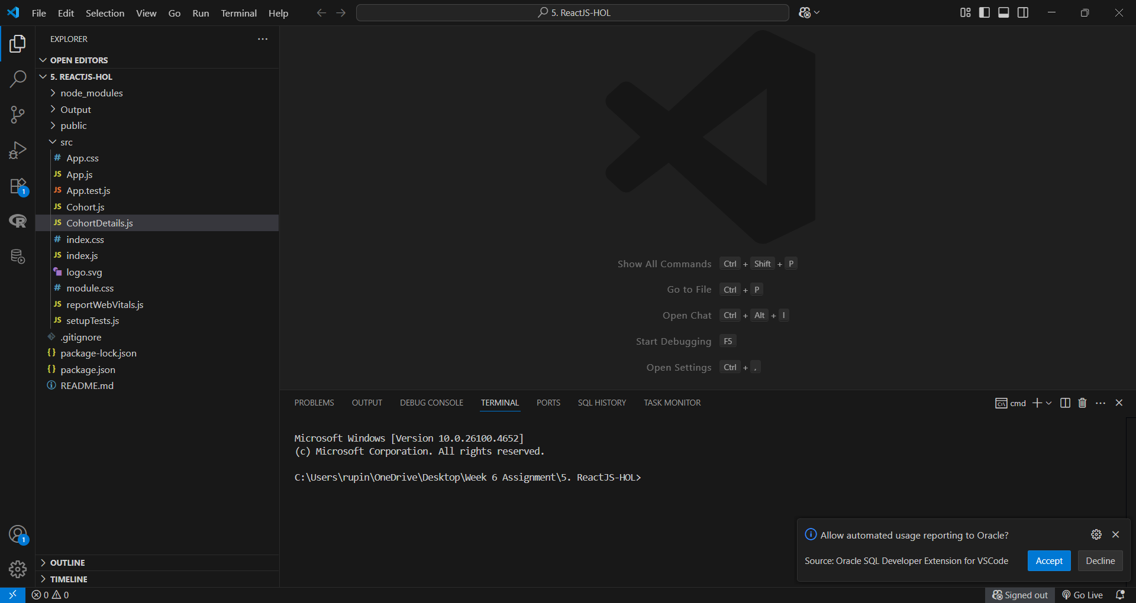

2.CohortDetails.js

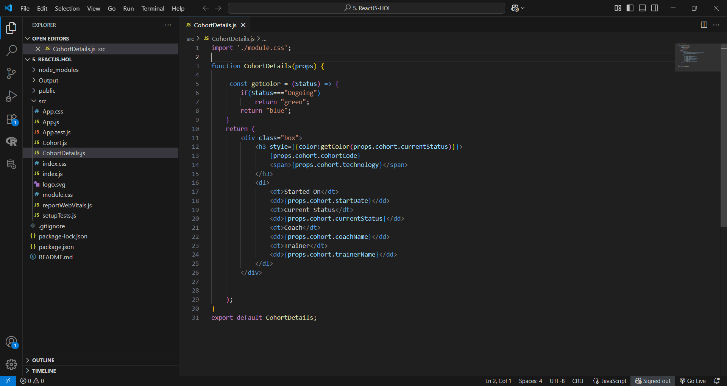

3.module.css

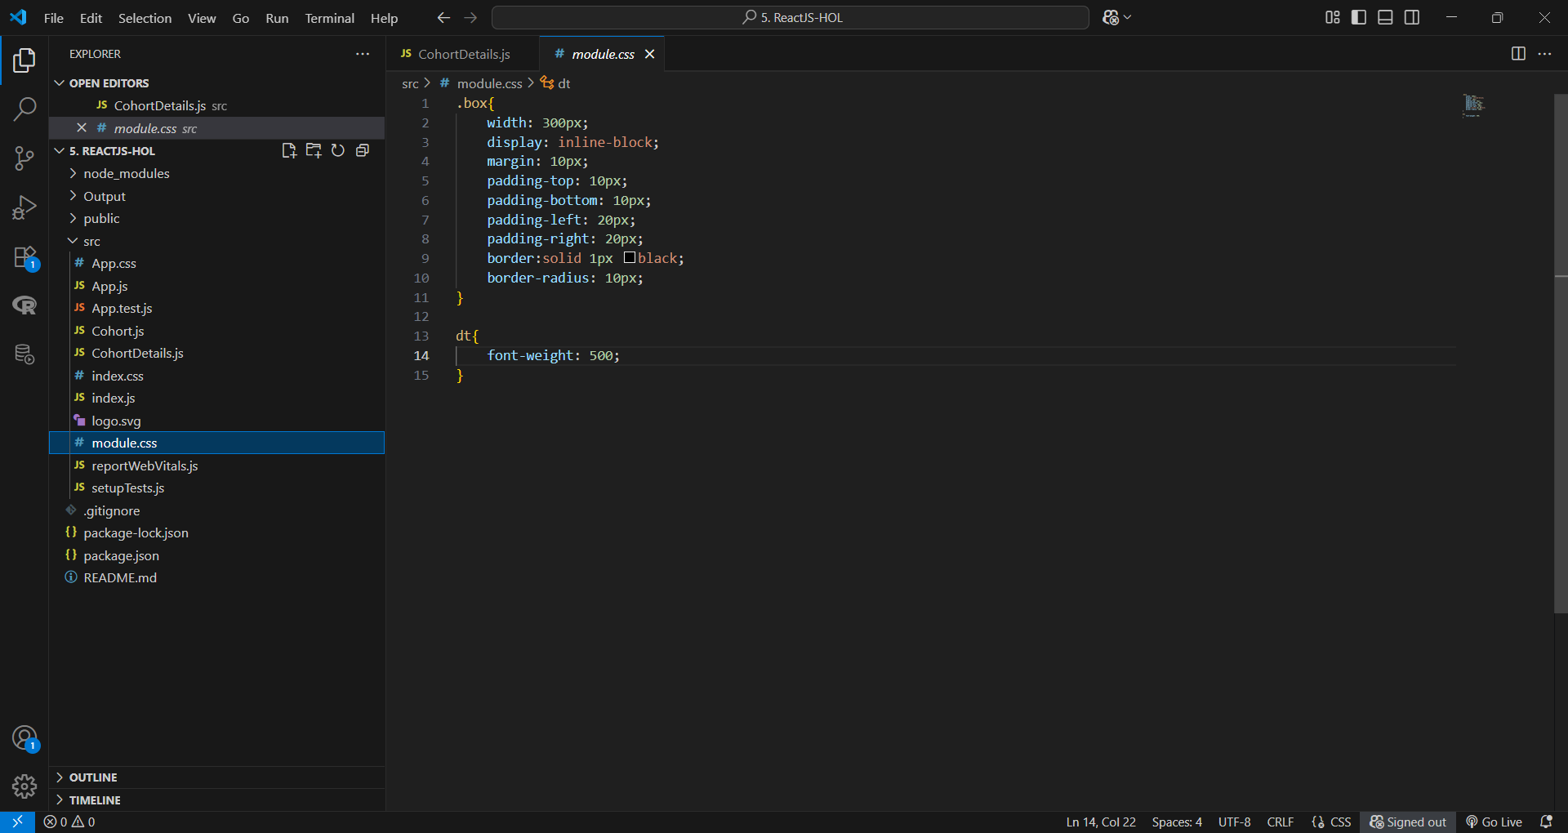

4.output

